Taichung Art Museum Art Supporting Project: 2027 Call for Entries
Application Guidelines

- Exhibition Overview:
To encourage artistic creation related to the following topics, the Taichung Art Museum (hereinafter referred to as “the Museum”) has established this call-for-entries project to invite curators from Taiwan and abroad to participate. The project welcomes submissions of diverse artistic works and exhibition proposals, with the expectation that creators will respond through art to current global and local issues, with particular emphasis on:
- Curations that are experimental, innovative, forward-looking, or cross-disciplinary in media or themes.
- Works that reflect current global or social issues, or echo the Museum’s sustainable operations.
- To build connections between the Museum, the city, schools, and communities.
Through this open call, the Museum aims to build an open, cross-disciplinary platform that provides diverse spaces for the presentation and performance of artistic creation.

- Exhibition Description: Art Supporting Project
- Visual arts exhibitions in any medium. Proposals must be adapted to the Museum’s exhibition spaces.
- The Museum will invite domestic and international curators and experts in relevant fields to serve as advisory mentors, and has established an observer system to work with selected applicants to complete the curatorial project. Applicants may propose preferred mentors when applying, and the museum will assist in matching mentors/mentees.
- Selected applicants must, as agreed, hold regular online or in-person meetings with mentors to discuss curatorial direction and submit meeting records or work logs.

- Exhibition Space: Exhibition Room A or B
(divided into two sections; for floor plans and details, please refer to Appendix 1; actual allocation determined by the Museum).

- Calendar:
Item | Date | Remarks
Submission | From the date of announcement until January 16, 2026 (by 23:59). | Submission via email only.
Review | Commenced in February–March 2026
Results Announcement | By March 13, 2026 | Please find the Museum’s official website.
Exhibition Period | Second half of 2027 | Each exhibition slot lasts approximately 16 weeks (including installation and deinstallation).  Final schedule to be arranged and adjusted by the Museum.

- Eligibility:
- Individuals or groups engaged in curation.
- No restriction on nationality or place of residence.
- Priority will be given to individual applicants or groups whose members are under the age of 40, as of the application deadline.

- Restrictions:
- Applications will not be accepted for institution/club presentations, graduation shows, promotion/award exhibitions, academic credit/degree projects, profit-making or religious activities.
- Submitted proposals must not have been publicly released.

- Number of Selections: 1 project will be selected, with 1 other on the waiting list.

- Funding & Support:
- Each selected project may receive up to NT$500,000 per exhibition area, subject to approval by the review committee. Contracts must be signed in accordance with the Government Procurement Act, and the Museum will withhold income tax and second-generation National Health Insurance premiums in accordance with relevant regulations.
- The funding includes curatorial fee, transportation of art works, installation and deinstallation, exhibition curation (carpentry, painting, and powered devices), design and printing of promotional materials, purchase and renting of exhibition equipment, and insurance.
- The Museum provides the exhibition space, assistance with arranging project mentors, consultants, and observers, as well as promotion (such as online platforms). The opening ceremony will be organized by the Museum.
- Applicants may seek additional funding from other organizations to cover costs exceeding the Museum’s grant.

- Application Materials:
- Application form (Appendix 2).
- Copy of identification (ID, residency permit, or passport) and copy of academic qualification; for group applicants, a copy of registration certificate of civil associations is required.
- Project Proposal must be written in Chinese or English (See Appendix 3), including:
    - Curatorial motivation and concept
    - List of works for the exhibition
    - Exhibition design and layout plan
    - Budget estimation
- Image/multimedia files of exhibited works should be uploaded to a personal cloud drive, with the URL provided in the application form (image files in JPEG format, max. 3MB per file; multimedia files in MP3/MP4 format, up to 3 minutes).
- Portfolio and other reference materials.
- Submitted materials will not be returned; applicants should keep copies for themselves.

- Application:
Download the forms from the Museum’s website (https://www.tcam. museum), and send them by email to: opencall@tcam.museum upon completion. Email subject line should read: “Taichung Art Museum Call for Entries – Art Supporting Project – Project Title – Applicant’s Name.” The Museum will confirm receipt of your application via email within 3 days after receiving it. If you do not receive a confirmation email within this period, please contact the project coordinator.

- Review Process: The Museum will invite internal and external experts and scholars to conduct a two-stage review. The first stage will be a document review, and the second stage will be an interview and presentation. Results will be announced separately.

- Evaluation Criteria: Proposals will be evaluated based on curatorial concept, exhibited works, spatial planning, and budget feasibility.

- Rights and Obligations:
- Proposals must consist of original, unpublished curatorial content and must not infringe upon the intellectual property rights of others. If infringement or other legal violations are found, the Museum may revoke or terminate the project. The applicant or awardee will bear full liability for compensation or legal responsibility. If damages occur to the Museum, the Museum reserves the right to pursue recovery of costs and return of fundings.
- Applicants with incomplete documentation must provide missing materials within the deadline specified by the Museum; failure to do so will be regarded as withdrawal.
- Selected applicants must sign a contract with the Museum within the specified timeframe; failure to sign will be regarded as withdrawal. The rights and obligations between the selected applicants and the Museum will be clearly stipulated in the contract.
- If unable to exhibit as scheduled, awardees must notify the Museum in writing no later than 5 months before the scheduled opening date. Failure to notify will result in disqualification from applying for the next 3 years. Failure to comply with the relevant regulations concerning exhibition arrangements shall likewise be deemed a waiver, and the applicant’s exhibition eligibility shall be revoked.
- Any changes to approved proposals must be submitted in writing and approved by the Museum; depending on circumstances, the Museum may re-review or cancel the project.
- Awardees must grant the Museum a non-exclusive, royalty-free license to use exhibition-related texts, images, and audiovisual materials for promotional and educational purposes (e.g., printed materials, website, press releases, digital media). Applicants may also be required to attend the exhibition opening and educational activities.
- Awardees are responsible for repairing or compensating for any damage to the Museum’s floors, ceilings, building elements such as columns, structural components, elevators, or equipment. For installation and deinstallation regulations, see Appendix 4. All events regarding installation and deinstallation must comply with the Regulations Governing Constructions at Taichung Art Museum Exhibition Space.
- Promotion and sale of artworks, as well as commercial activities of any kind are prohibited during the exhibition period.
- Submission of application materials will be regarded as an agreement to abide by all rules stated in these guidelines.
- In case of force majeure such as natural disasters or pandemics, the Museum reserves the right to adjust these guidelines, relevant regulations, and contracts.
- The Museum retains the final right of interpretation of the aforementioned rights and obligations. Matters not covered in these guidelines may be amended as necessary.

- Contact Information:
Curatorial Department, Taichung Art Museum
Address: No. 2201, Zhongke Road, Xitun District, Taichung City 407011, Taiwan
Tel: +886-4-2369-6333 ext. 563 (Ms. Huang)

Appendix 1

Floor Plan of Exhibition Room A (Indoor ceiling height: 9 meters.)
3D space preview：https://artogoco.pse.is/89lwvf

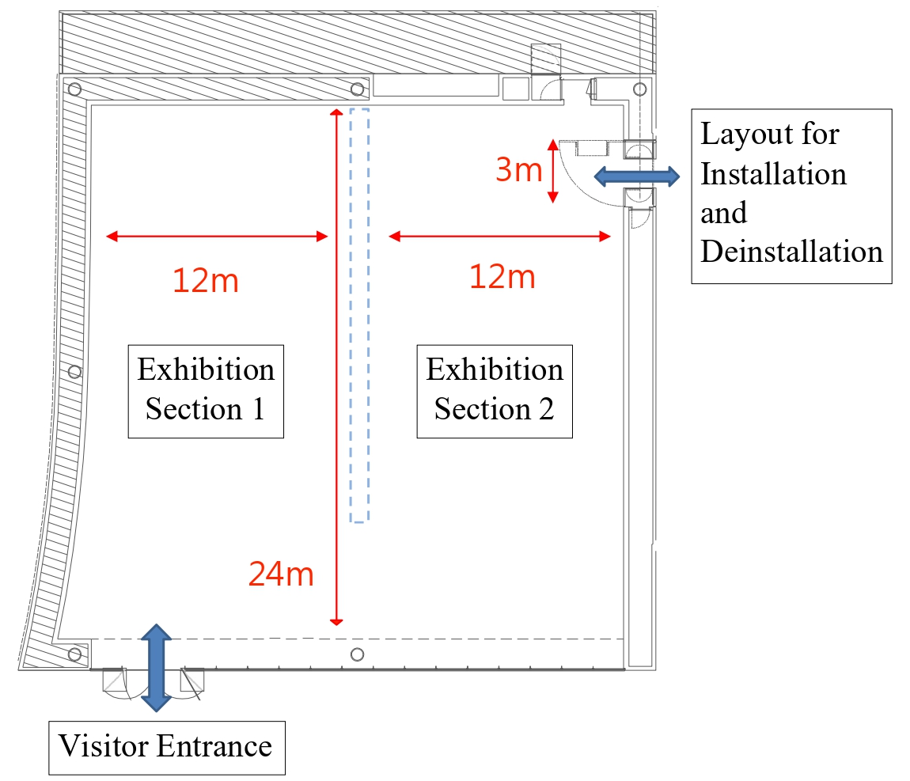

- The height and area of the exhibition rooms vary. Applicants may choose either Exhibition Room A or B according to the characteristics of their works. Each exhibition room is divided into two sections, and applicants may decide to use one or both zones for their display. Final arrangements will be confirmed with the Museum once the project is selected.
- The layout and wall positions are for reference only. Final arrangements will be confirmed with the Museum once the project is selected.

Floor Plan of Exhibition Room B (Indoor ceiling height: 4 meters.)
3D space preview：https://artogoco.pse.is/89lwwj

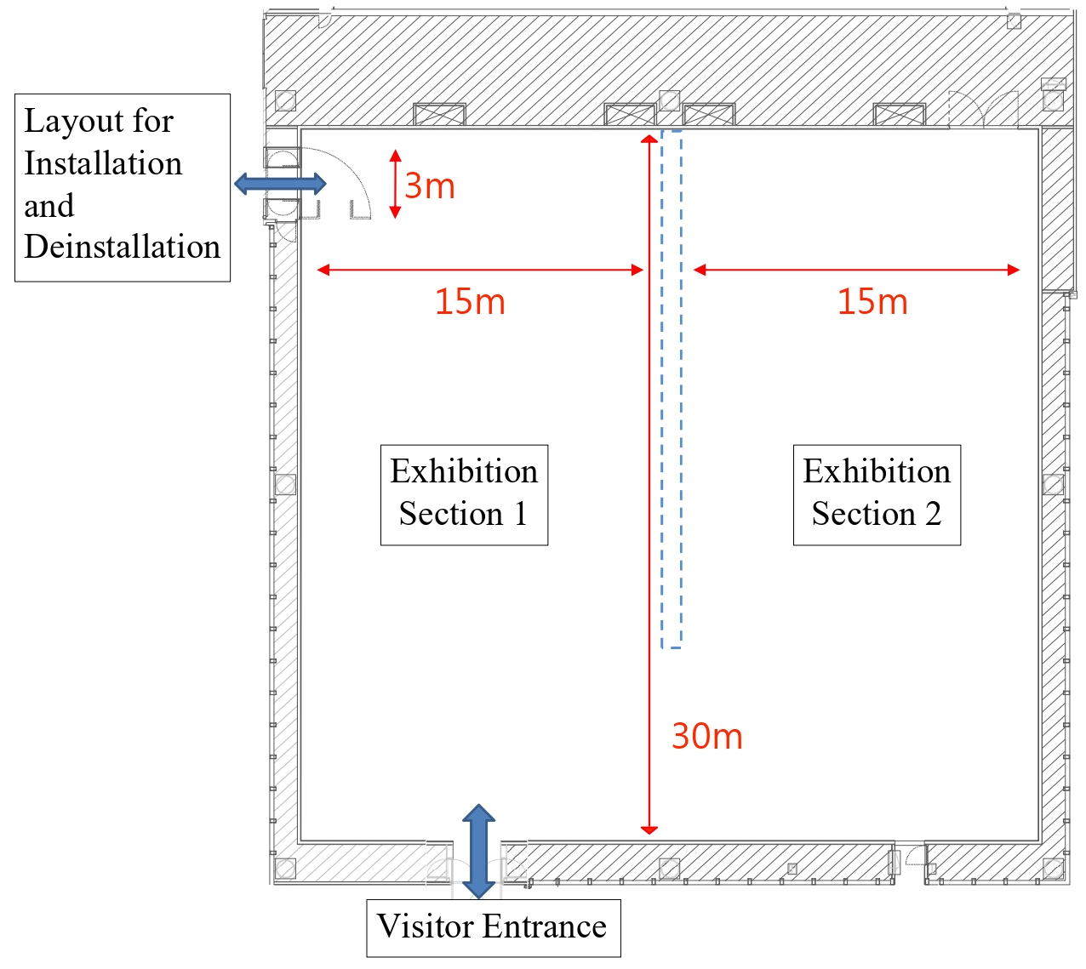

- The height and area of the exhibition rooms vary. Applicants may choose either Exhibition Room A or B according to the characteristics of their works. Each exhibition room is divided into two sections, and applicants may decide to use one or both zones for their display. Final arrangements will be confirmed with the Museum once the project is selected.
- The layout and wall positions are for reference only. Final arrangements will be confirmed with the Museum once the project is selected.

Appendix 2
Application Form for Taichung Art Museum Art Supporting Project
Chinese Name | If applying as a group, please fill in the representative’s name | Application No. | To be filled by the Museum
English Name |  | Gender |  | Nationality
ID No. | Group applicants should provide the registration number of civil associations and attach a copy of registration certificate | Date of Birth | Group applicants should fill in date of establishment  Year Month Day
Email Address |  | Phone No. Mobile No. | （ ）
Permanent Address | □□□-□□□
Mailing Address | - check if same as permanent address
Curriculum Vitae
Education | Individual applicants should fill in this column and attach a copy of the highest degree certificate; group applicants are exempt
Awards/  Professional Experience/  Exhibition Experience/  Major Publications | Group applicants should provide a group profile

Appendix 3

Project Proposal for Taichung Art Museum Art Supporting Project

Project Title
Curatorial Motivation and Concept
Required Documents |  | □ Copy of identification (front and back of an ID card for individual applicants / registration certificate of civil associations for group applicants)  □ Copy of highest degree certificate  □ Portfolio or other reference materials
Applicant’s Signature |  | I have read and agreed to comply with the guidelines for this exhibition.  To: Taichung Art Museum  Applicant (Signature): ____________________  Date: ____ / ____ / ____ (YYYY/MM/DD)

List of Works for the Exhibition
Cloud drive URL to digital files of works:
No. | Artist | Title | Year | Medium | Dimensions
Example | Lin, XX | XXXX | 2024 | Oil on Canvas | 88.5 × 51 cm
1
2
3
4
5
6
7
8
9
10
11
12
13
14
15

- Add rows if necessary.
- Naming format for digital files of works: “No.–Title”.

Exhibition Design and Layout Plan
Preferred Exhibition Room:
□ Exhibition Room A □ Exhibition Room B

Budget Estimation (NT$)
Item | Unit | Quantity | Unit Price | Amount | Remarks
Total |  |  |  | NTD
- Add rows if necessary.

Other Funding Sources (Leave blank if none) (NT$)
Name of Organization / Company | Application Date | Amount | Remarks
- Add rows if necessary.

Appendix 4
Taichung Art Museum: Call-for-Entries Project
Regulation of Installation and Deinstallation

      - Packaging and Transportation:
- The exhibitor shall package and transport all works to and from the venue and ensure their integrity.
- The exhibitor shall provide the Museum with a complete work list and condition report 1 month prior to installation, and shall conduct joint inspection with the Museum upon delivery and sign a confirmation form.
- All works shall arrive at the museum no earlier than 2 weeks before the exhibition start date and shall be fully installed 2 days before opening for cleaning, testing, and lighting adjustments.
- The exhibition venue shall be restored with all works deinstalled and waste removed within 1 week after the exhibition ends by the exhibitor. The Museum shall not be liable for storage beyond this period.

      - Installation, Display, and Deinstallation:
- The exhibitor shall procure and maintain fine art insurance covering the packaging, transportation, and the entire duration of the exhibition, with the Museum expressly named as an additional insured. Insurance certificates must be submitted to the Museum for record-keeping prior to installation.
- All personnel taking part in installation, deinstallation, and services during the exhibition period must wear the ID badges provided by the Museum at all times for identification purposes.
- The exhibitor shall be responsible for exhibition design and installation. The Museum may assist if necessary.
- Exhibition design and installation shall be conducted under the Museum’s approval, and the exhibitor shall not display or install any objects or devices unrelated to the exhibition, or that may endanger the safety of the Museum or any third party; otherwise, the Museum retains the right to terminate such installations. Should such violation cause damage to the Museum or any third party, the exhibitor shall bear liability for compensation.
- Any change to the exhibited content or layout shall be mutually agreed upon and carried out by the exhibitor.
- During installation and deinstallation, all artworks must be transported via the Museum’s designated transport routes and freight elevator. Protective measures must be taken to prevent any damage to the Museum’s structural components such as elevators, floors, walls, and ceilings
- The floor of exhibition rooms features a load capacity of 500 kg/m² and the walls support up to 50 kg/m². The wall structure, from outermost to innermost layer, consists of 1.5 cm gypsum board, 1.2 cm plywood, and 1 cm cement board. Nails or fasteners must be driven at least 2.5 cm deep to ensure adequate support.
- During deinstallation, exhibition walls must be restored to a smooth and color-consistent condition using putty and custom paint colors; please contact the Museum for the paint brand and color code. Drilling or nailing is strictly prohibited on the floor, columns, ceiling, or structural elements of the exhibition space.
- After the end of exhibitions, the venue must be restored to its original condition prior to the exhibition, including patching and repainting of walls; ensuring no damage to the Museum’s floors, ceilings, columns, structural elements, and elevator; as well as cleaning the venue and removing exhibits and waste. If any damage occurs during installation, deinstallation, or the exhibition period, the exhibitor shall restore the affected facilities using original materials and methods or otherwise bear liability for compensation. Should the exhibitor fail to restore the venue within the specified timeframe, the Museum reserves the right to carry out the restoration and waste removal on their behalf and charge the exhibitor accordingly.
- After deinstallation, the exhibitor must conduct joint inspection with the Museum upon delivery of venue and equipment, submit a deinstallation report (including photos), and sign a confirmation form.
- Any equipment required for the exhibition (including but not limited to monitors, players, projectors, computers, and similar devices), any special equipment necessary for installation art, as well as consumable materials intended for audience interaction, shall be prepared solely by the exhibitor. Where the exhibited content is presented in digital format, the exhibitor shall be responsible for making and retaining backup copies. Should the exhibitor wish to insure any digital content, the exhibitor shall be solely responsible for procuring such insurance.
- For exhibitions featuring sound-based works, soundproofing measures must be taken by the exhibitor to prevent disturbance to other exhibition spaces and ongoing events.
- The Museum shall provide existing art lighting equipment for the exhibitor’s use. The exhibitor shall complete an application form, and such equipment shall only be provided upon the Museum’s approval. In the event of any damage, the exhibitor shall compensate the Museum at cost. If the Museum’s existing lighting equipment is insufficient, the exhibitor shall procure additional lighting equipment at its own expense. The exhibitor shall be solely responsible for any damage to such equipment, and if such damage causes harm to the Museum or any third party, the exhibitor shall bear liability for compensation.
- If the Museum determines that the exhibited works present concerns of pest infestation or other sources of contamination, the exhibitor shall complete all necessary preventive measures prior to the delivery of the exhibited works to the Museum’s premises. Should the exhibitor fail to implement such preventive measures, the exhibitor shall bear full responsibility for any damage to its own exhibited works. In the event such failure results in damage to the Museum or any third party, the exhibitor shall be liable for compensation.
- The exhibitor shall not alter, dismantle, occupy, or obstruct any safety facilities, including but not limited to fire protection systems, emergency exits, surveillance equipment, evacuation routes, and signage systems. The exhibitor must keep all passageways clear during installation, deinstallation, and the exhibition period. Blocking fire exits or emergency escape routes with any items is strictly prohibited. If a violation of this provision causes damage to the exhibited works, the exhibitor shall be solely responsible. Should such violation cause damage to the Museum or any third party, the exhibitor shall restore the affected facilities and artworks using original materials and methods or otherwise bear liability for compensation.
- The exhibitor shall not display price tags on artworks or placing catalogs with prices; promotion and sale of artworks is also prohibited.
- If the exhibited works involve the use of electronic equipment, the exhibitor shall, upon completion of the installation, provide the Museum with illustrated operating instructions and a troubleshooting manual to facilitate routine maintenance as well as opening and closing operations of the venue. Technical training sessions shall also be arranged if needed.
- If exhibited works are damaged or malfunctioning, the exhibitor shall repair them within 3 days of the Museum’s notice and notify the insurer if necessary.
- Flower baskets, wreaths, potted plants, or any objects or devices unrelated to the exhibition shall not be displayed or installed.
- In addition to the above regulations, all construction must comply with the Regulations Governing Constructions at Taichung Art Museum Exhibition Space.

      - Publicity:
- The use of the Museum’s logo in promotional materials must comply with the official usage guidelines and is strictly limited to the intended exhibition. All content must be reviewed and approved by the Museum prior to printing.
- The Museum shall provide the equipment and designated space for the display or posting of exhibition promotional materials. Posting or distributing such materials without permission is strictly prohibited.

      - Miscellaneous:
- Eating, drinking, smoking, chewing betel nuts, and chewing gum are strictly prohibited within the Museum’s premises.
- During the exhibition period, no solicitation, sales, or any commercial activities are allowed within the Museum premises.
- Animals and plants are prohibited for entry, except for guide dogs.
- The term “day” in these regulations refers to calendar days.
- The Museum reserves the right to amend or supplement these guidelines at any time should any omissions or inadequacies arise.

